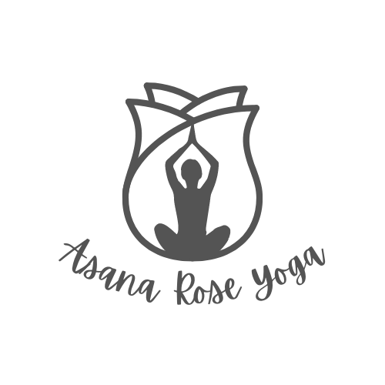

Agreement of Release and Waiver of Liability

Name: ___________________________________________________________________________
Phone: ________________________Email: _____________________________________________
Address: _________________________________________________________________________
City: ______________________State: ________Zip: _______________DOB: __________________

Emergency Contact
Name: _______________________________________________ Phone: _____________________

I, _____________________________________, hereby agree to the following:
1. That I am participating in the Yoga Classes, breathing exercises and meditation practices offered by Asana Rose Yoga during which I will receive information and instruction about yoga, fitness, and health. I recognize that yoga, and other exercise fitness routines require physical exertion that may be strenuous and may cause physical injury, and I am fully aware of the risks and hazards involved.
2. I understand that it is my responsibility to consult with a physician prior to, and regarding my participation in Yoga Classes, as well as other exercise fitness routines, Health Programs, or Workshops offered by Asana Rose Yoga. I represent and warrant that I am physically fit, and I have no medical condition that would prevent my full participation in the Yoga Classes, as well as breathing exercises or meditation practices. I understand that it is my responsibility to update this waiver regarding any health condition changes that I experience in the future.
3. In consideration of being permitted to participate in Yoga Classes, as well as breathing exercises or meditation practices, I agree to assume full responsibility for any risks, injuries or damages, known or unknown, which I might incur as a result of my participation.
4. In further consideration of being permitted to participate in Yoga Classes, as well as breathing exercises or meditation practices, I knowingly, voluntarily and expressly waive any claim I may have against Asana Rose Yoga for injury or damages that I may sustain as a result of participating in the program, and as a result of my negligence in participating in this activity.
5. I, my heirs, and/or legal representatives’ forever release waive, discharge and covenant not to sue Asana Rose Yoga for any injury or death caused by their negligence or other acts.

I have read the above release and waiver of liability and fully understand its contents. I voluntarily agree to the terms and conditions stated above. I realize there are special risks that could be associated with pregnancy, prior surgeries, injuries, and medical conditions that may carry additional health concerns. I have discussed these with my personal physician, and I have obtained his or her concurrence to participate in activities offered by Asana Rose Yoga I fully understand that Asana Rose Yoga instructors and staff are not medically trained physicians or experts in medicine, and therefore, realize that their guidance is limited to the practice of yoga and fitness exercise, and the techniques and routines associated with them.

This agreement shall be governed by the laws of the State of Texas.

I am not relying on any oral, written, or visual representations or statements made by Asana Rose Yoga, including brochures or promotional materials to induce me to participate in this activity.

I have read the above release and waiver of liability and fully understand its contents. I voluntarily agree to the terms and conditions stated above.

Signature: _______________________________________ Date: ________/________/________

Witness: _________________________________________ Date: ________/________/________

